Git and Github assignments

1. Create a new GitHub repository.
- Clone the repository to your local machine using SSH (generate an SSH key if needed, add the public key to your GitHub account).
- Create a new branch named after your username (e.g., Tutedude).
- Add your Flask project files to this branch.
Commit the changes and merge the branch into the main branch.

Solution -

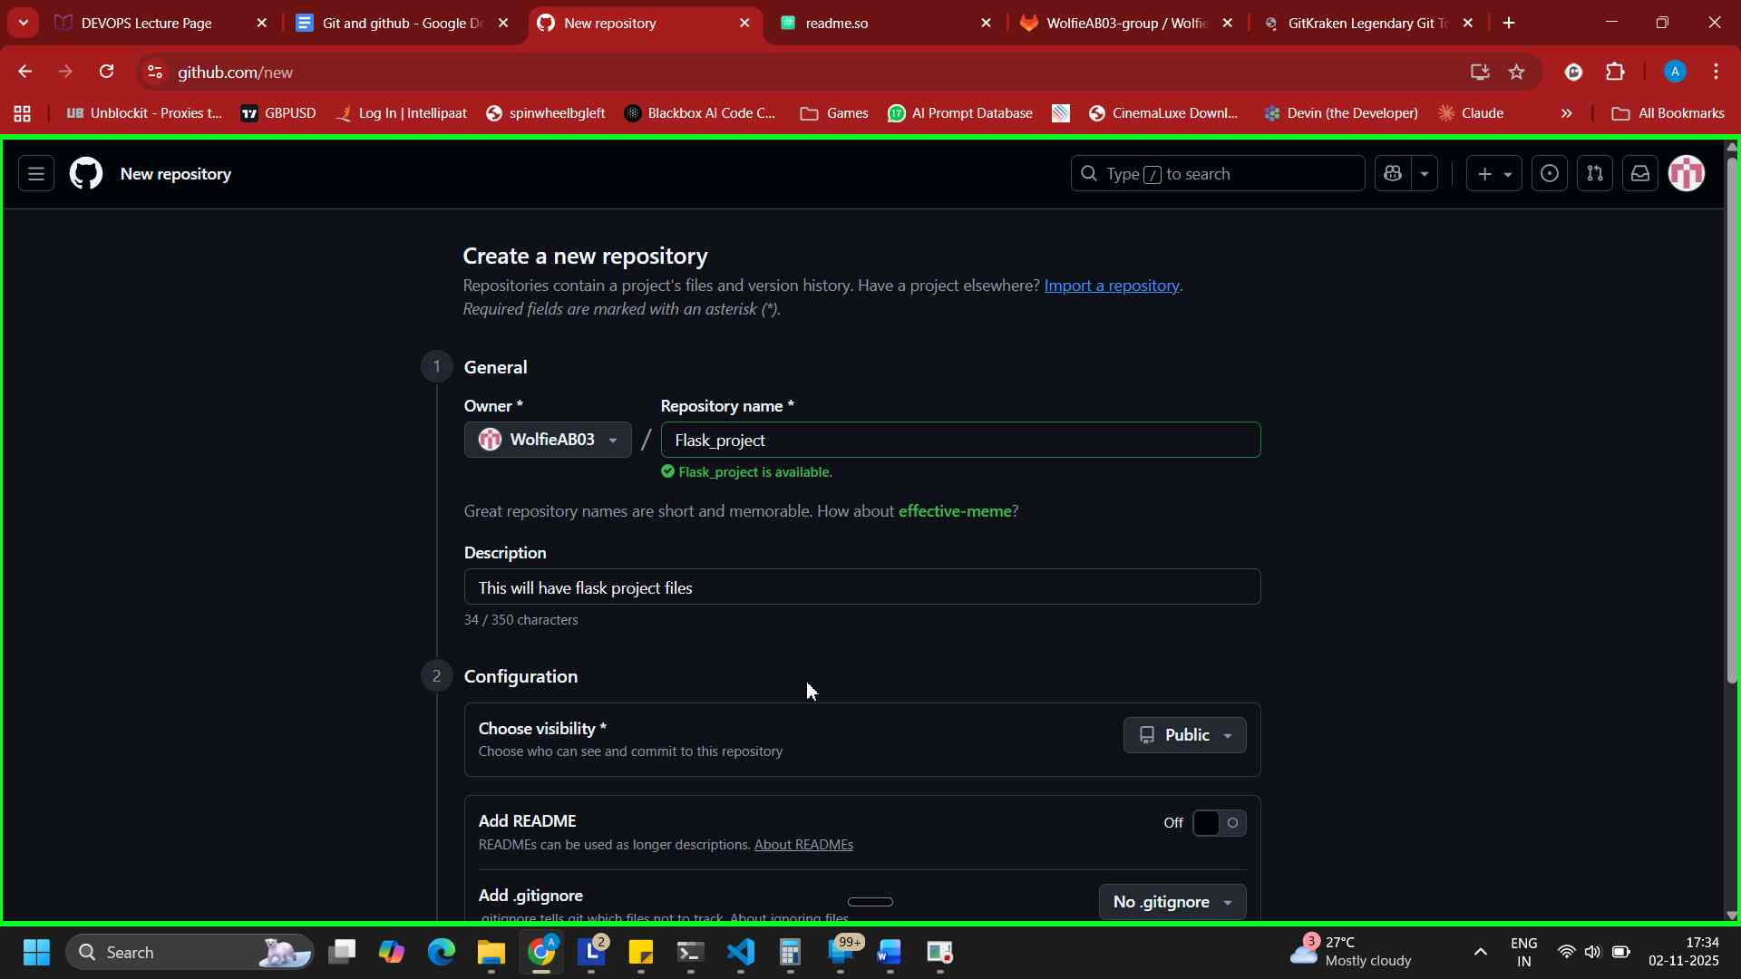
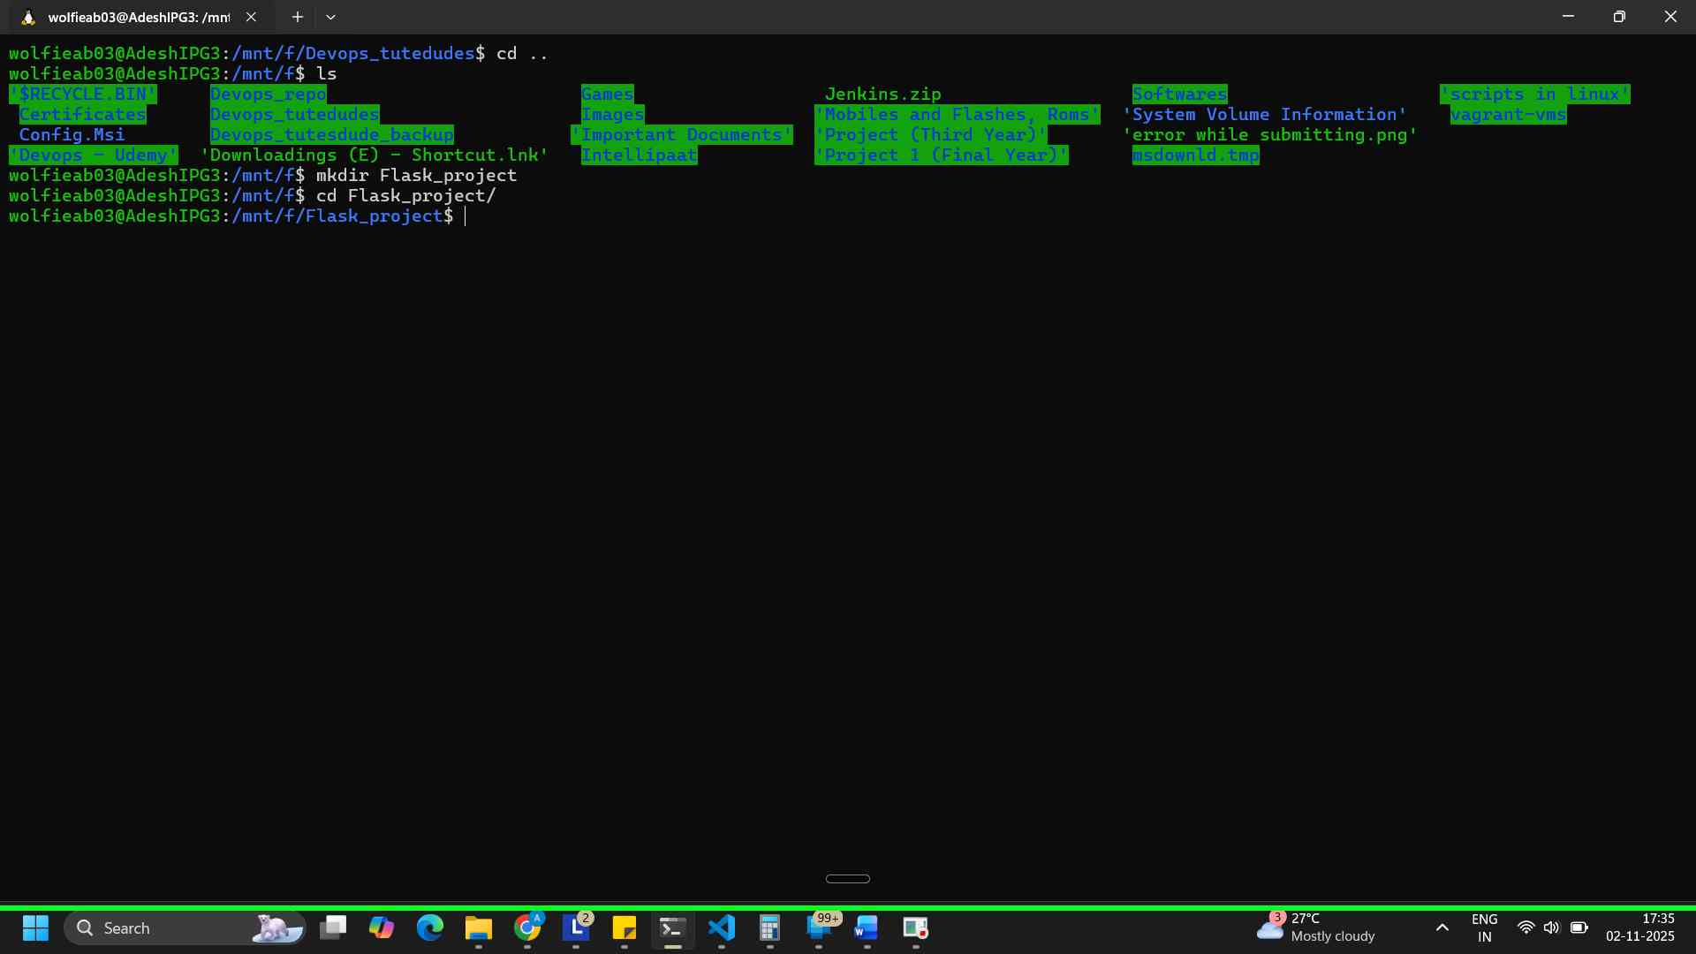

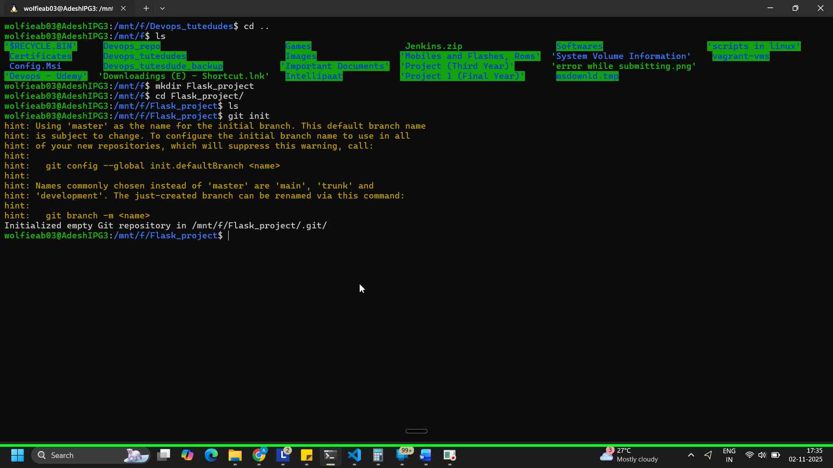
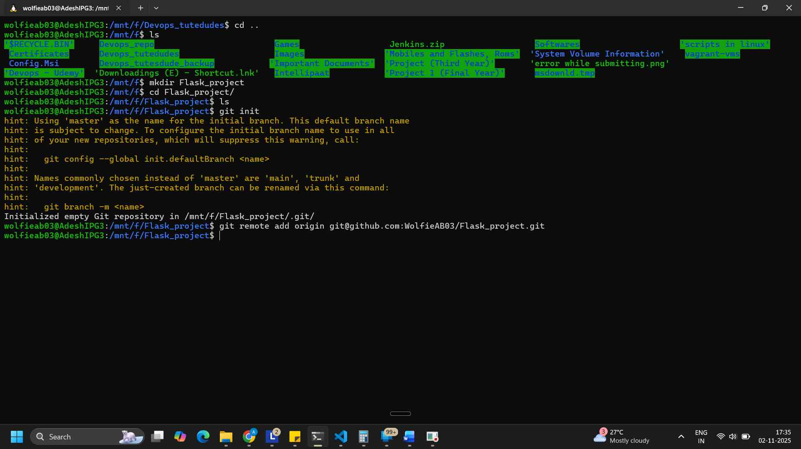
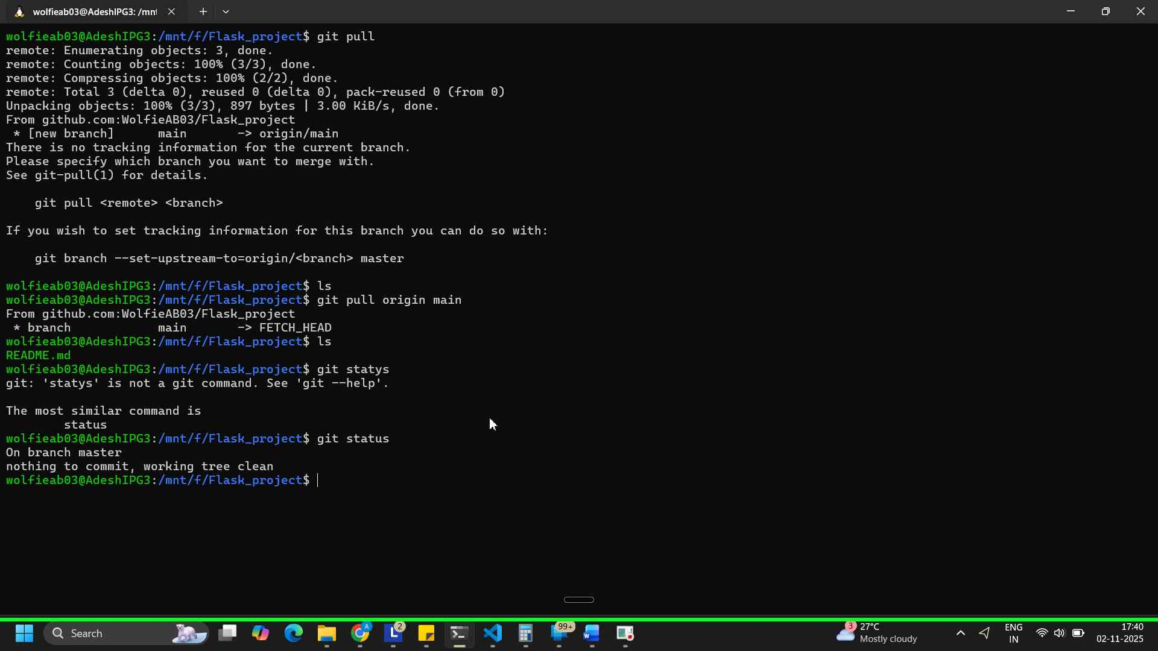
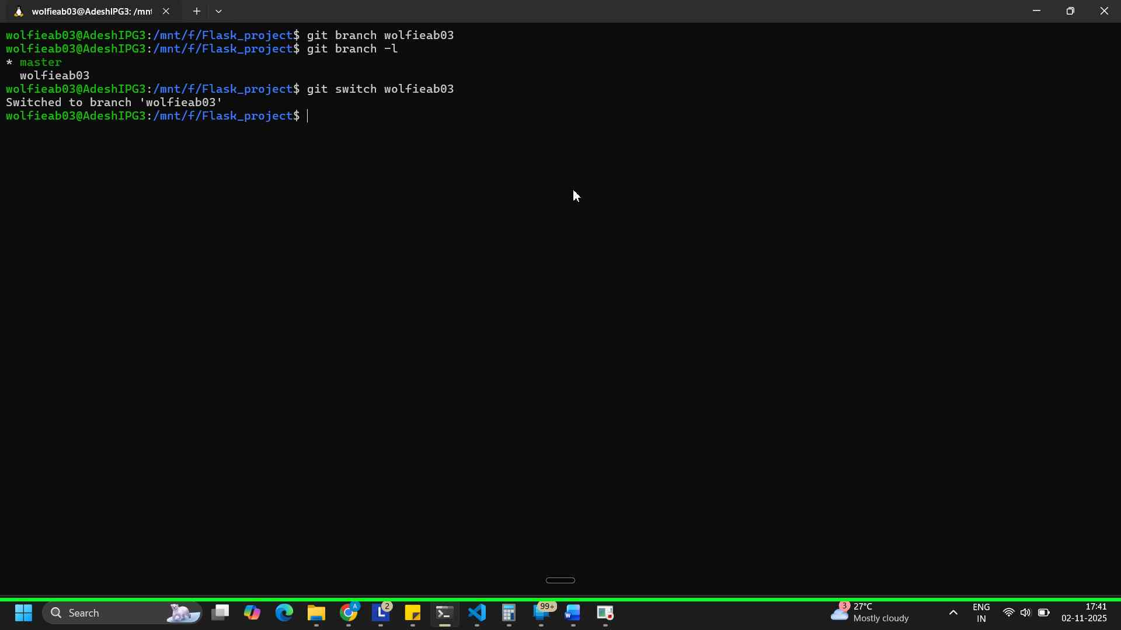
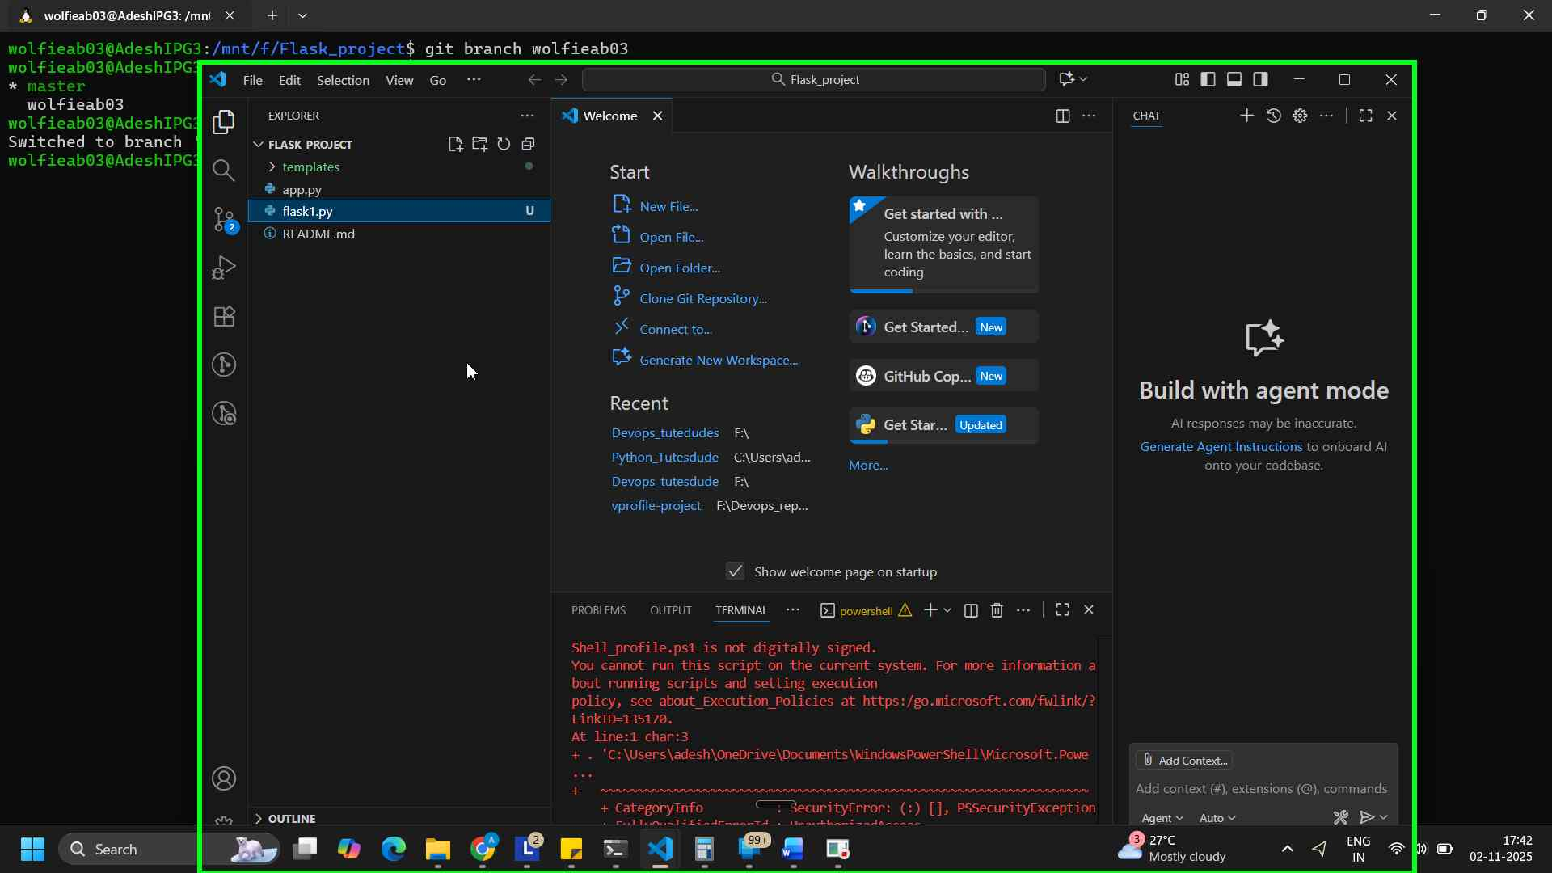
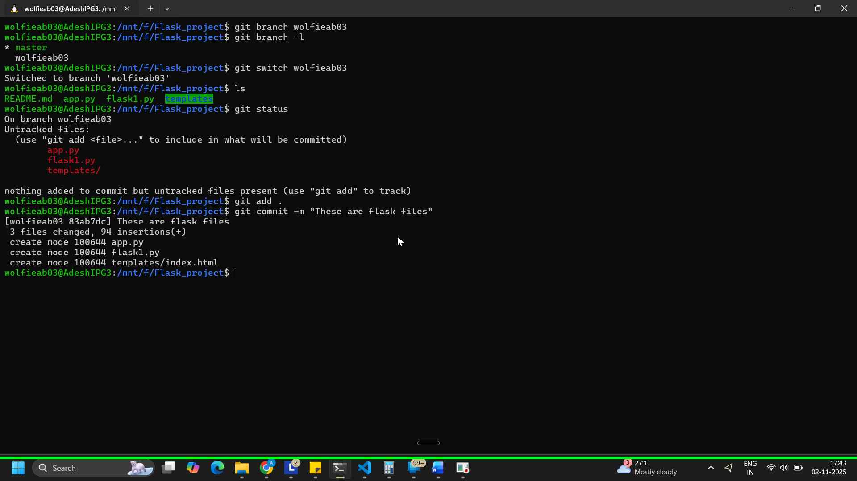
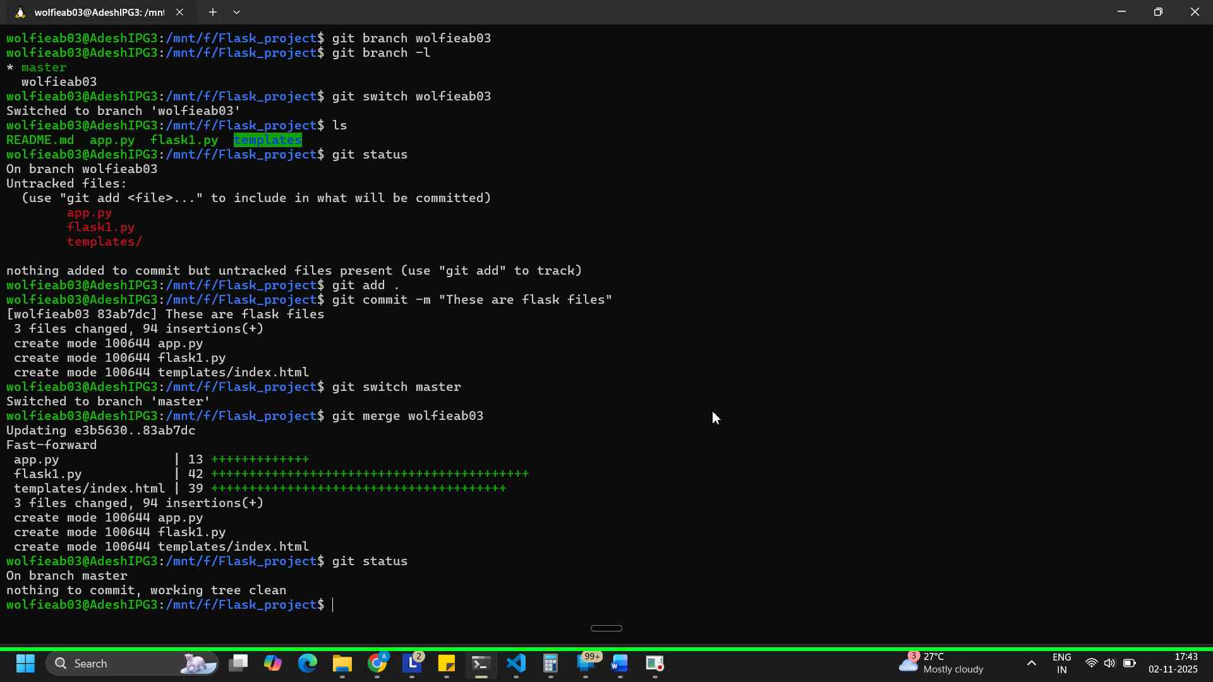

2. Create a new branch named <your_name>_new (e.g., Tutedude_new).
- Update the content of the JSON file used for the /api route in this branch.
- Merge the <your_name>_new branch into the main branch.
- If there are conflicts during the merge, resolve them by accepting the changes from the <your_name>_new branch.
- Add the resolved changes to the staging area, commit them, and push the updates to the remote repository.

Solution -

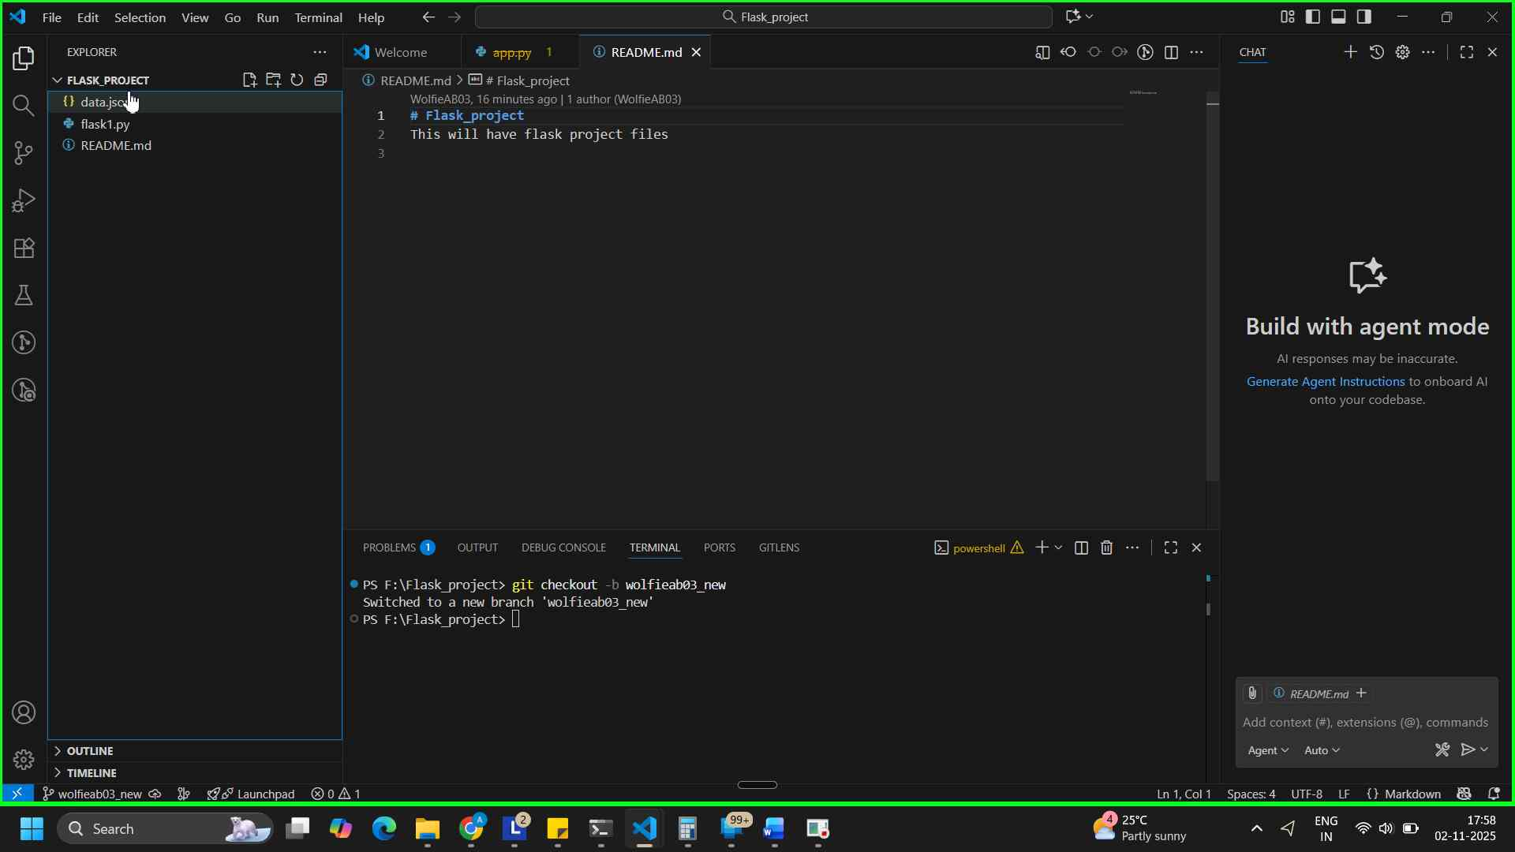
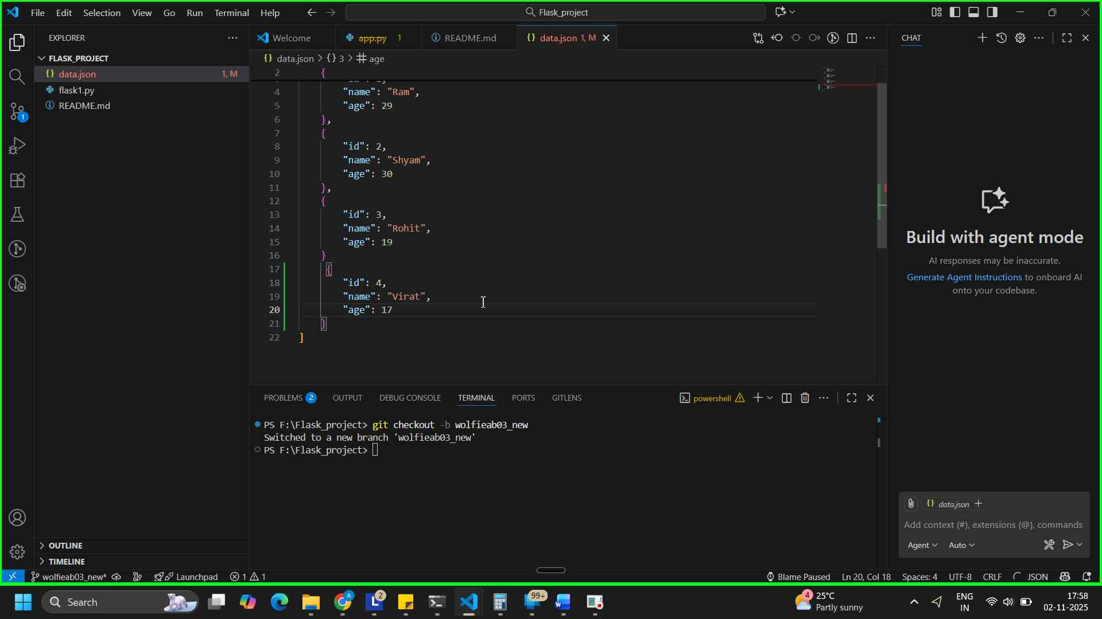
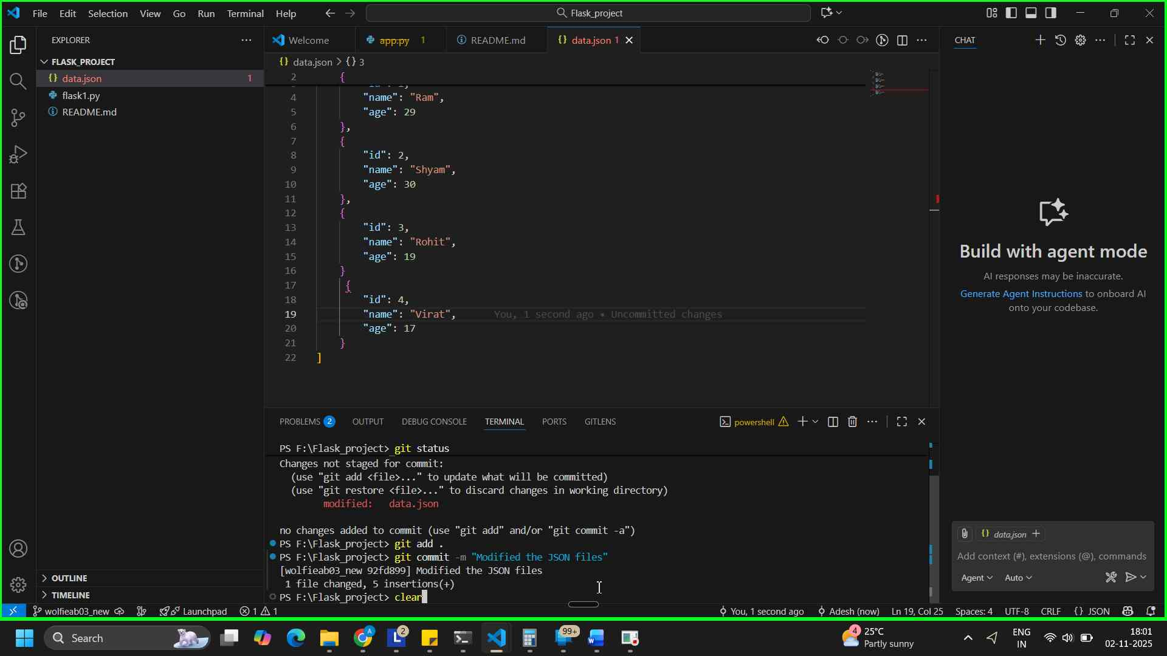
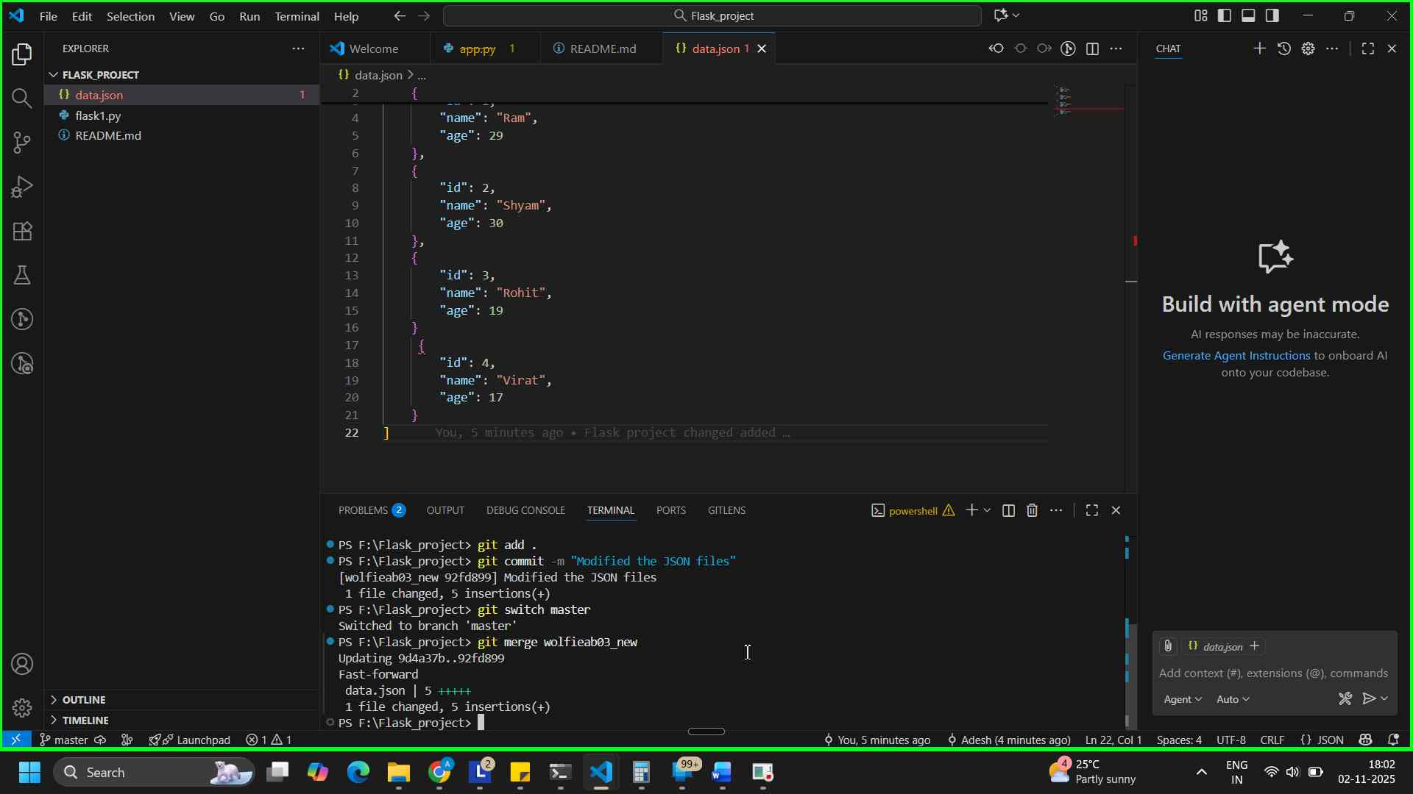
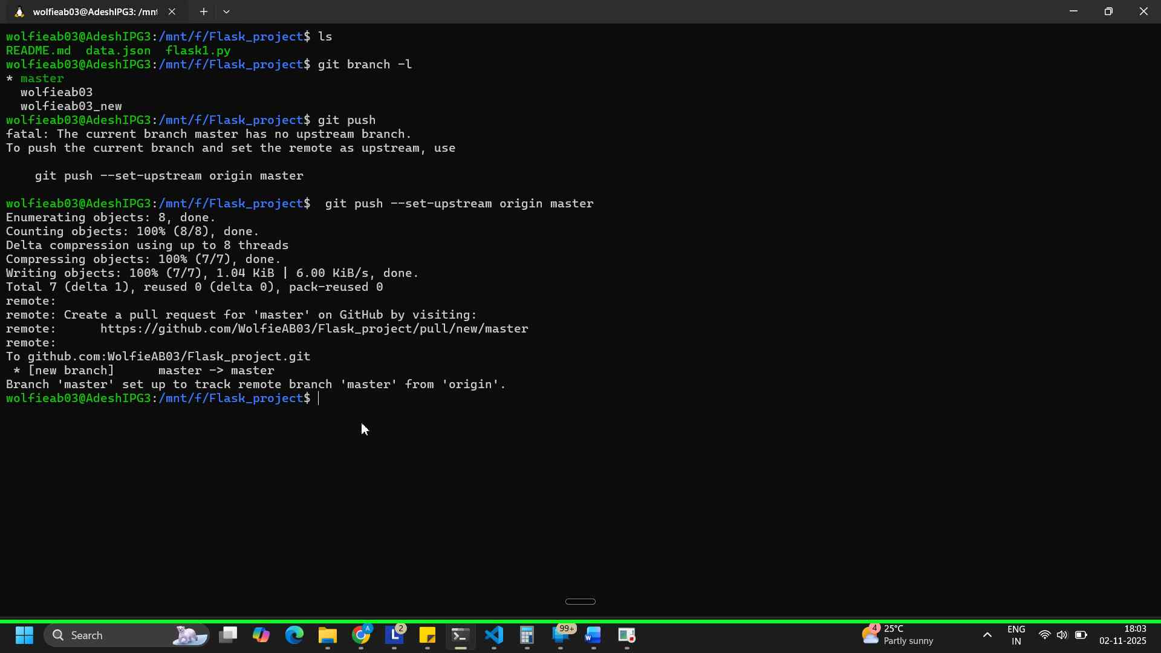
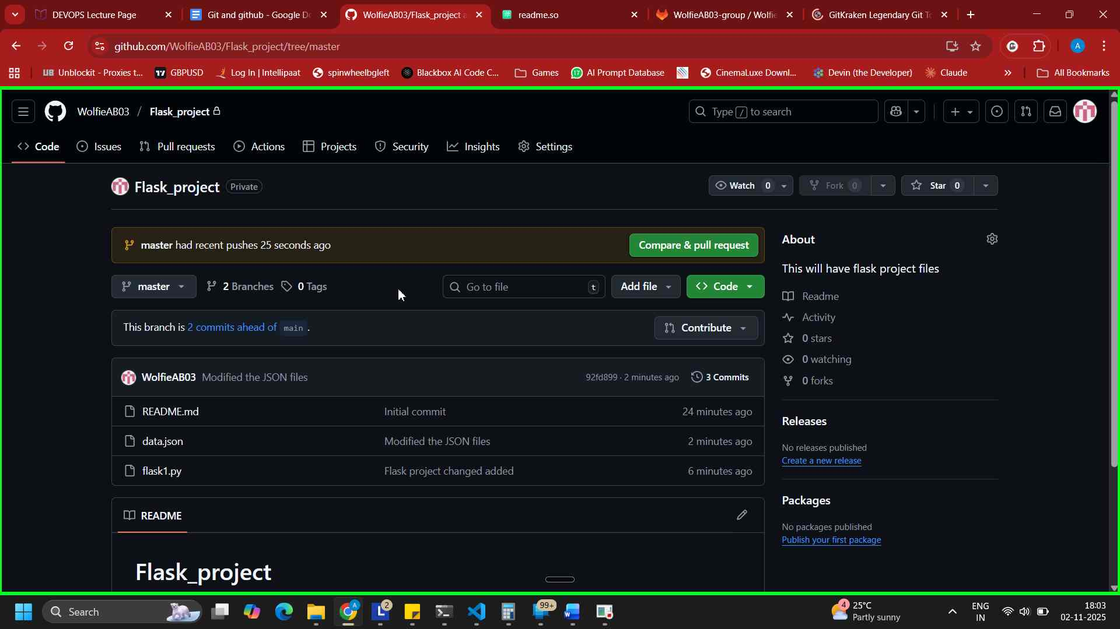

3. Branch Creation:
- Create two branches: master_1 and master_2 from the main branch.
- Feature Development in master_1:
- In the master_1 branch, create a To-Do Page in the frontend.
  - The page should contain a form with the following fields:
    - Item Name
    - Item Description
- Backend API in master_2:
- In the master_2 branch, create a backend route named /submittodoitem.
- This route will:
  - Accept itemName and itemDescription via a POST request.
  - Store these details in a MongoDB database.
- Merging Changes:
Merge the changes from both master_1 and master_2 into the main branch.

Solution –

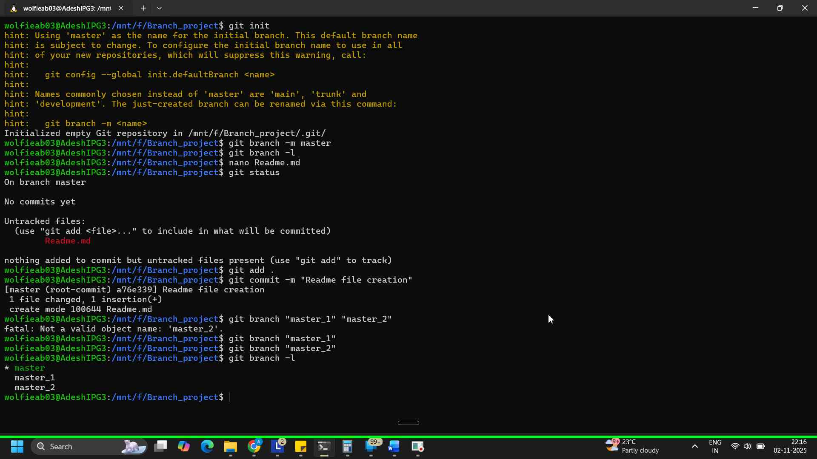
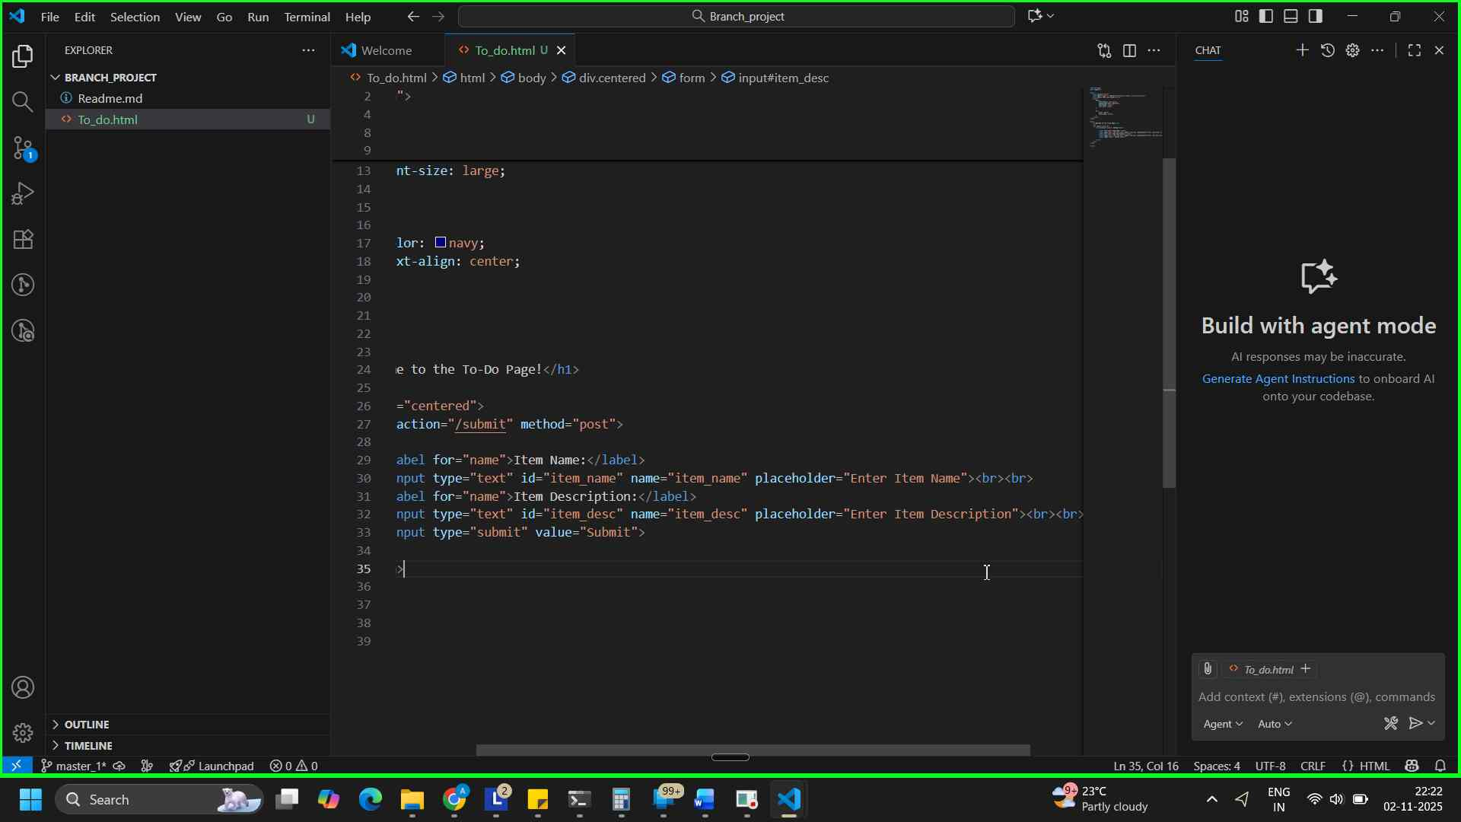
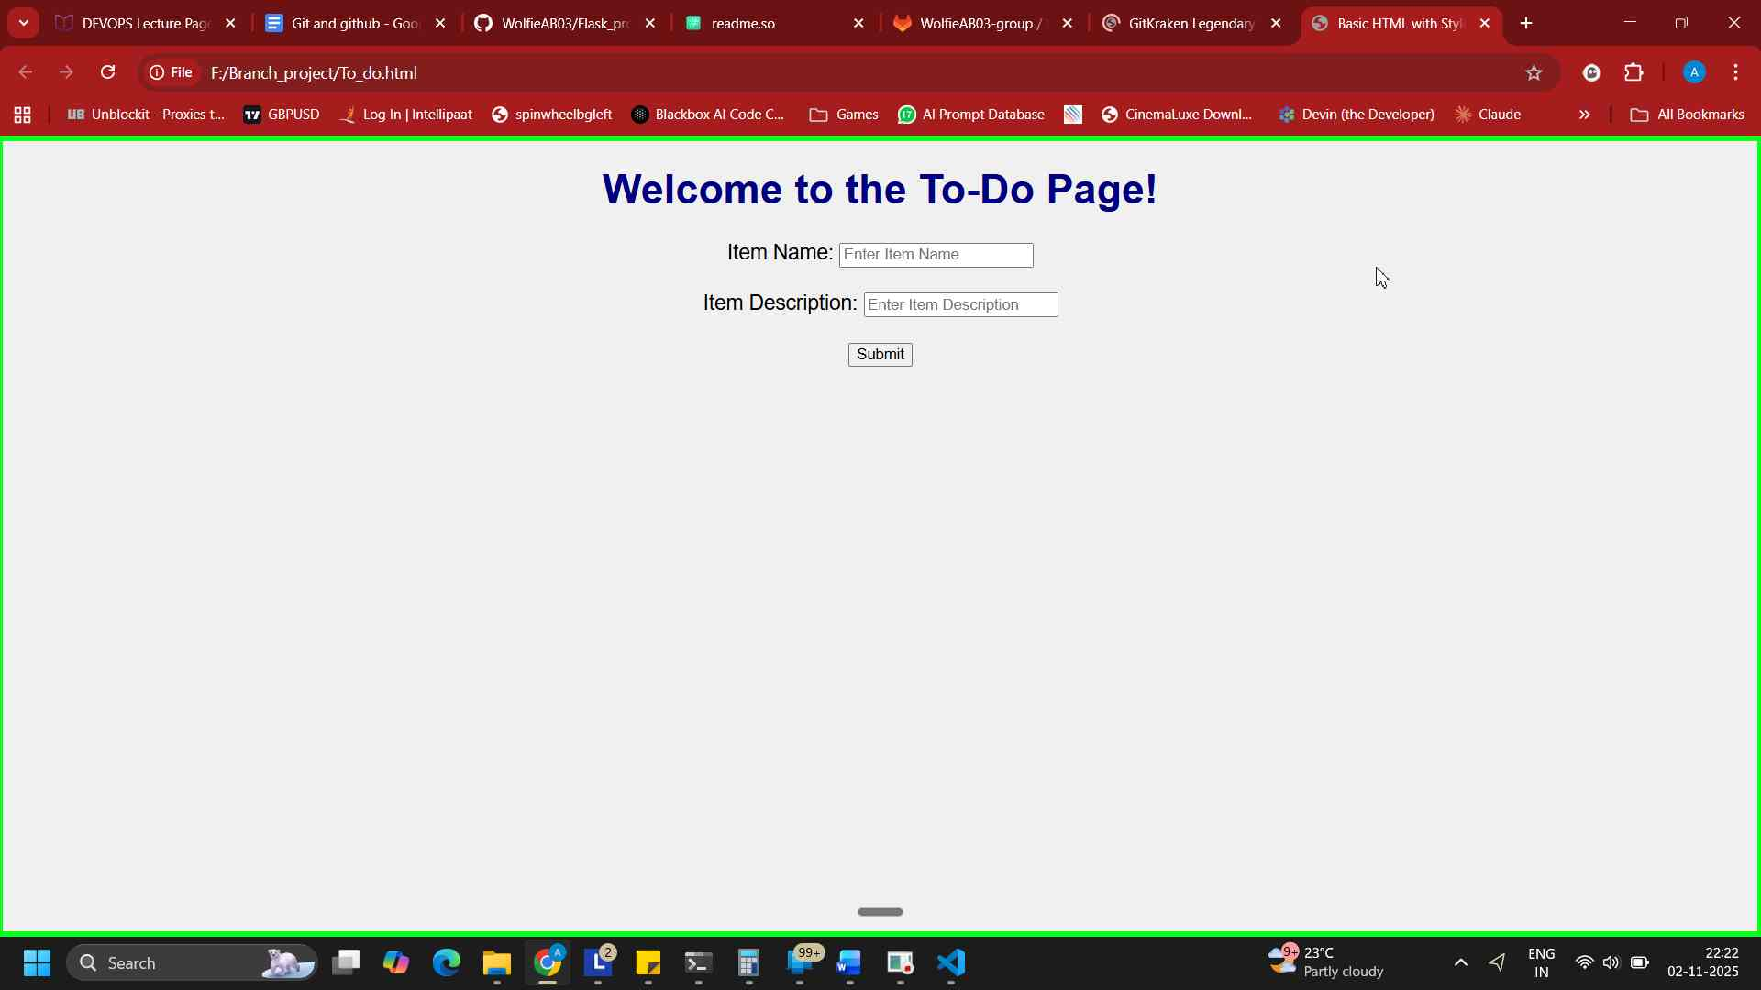
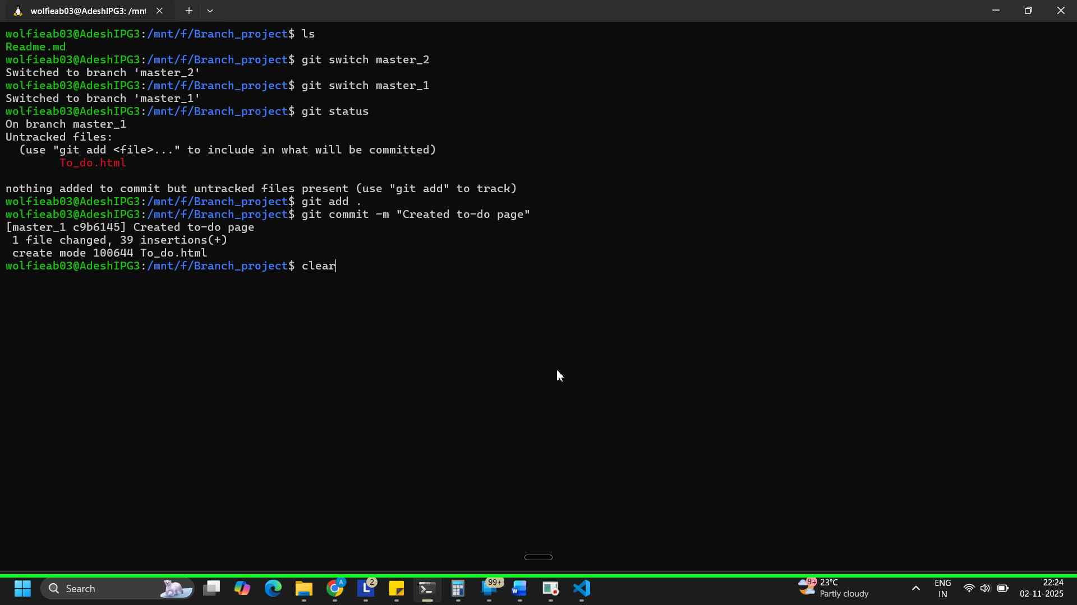
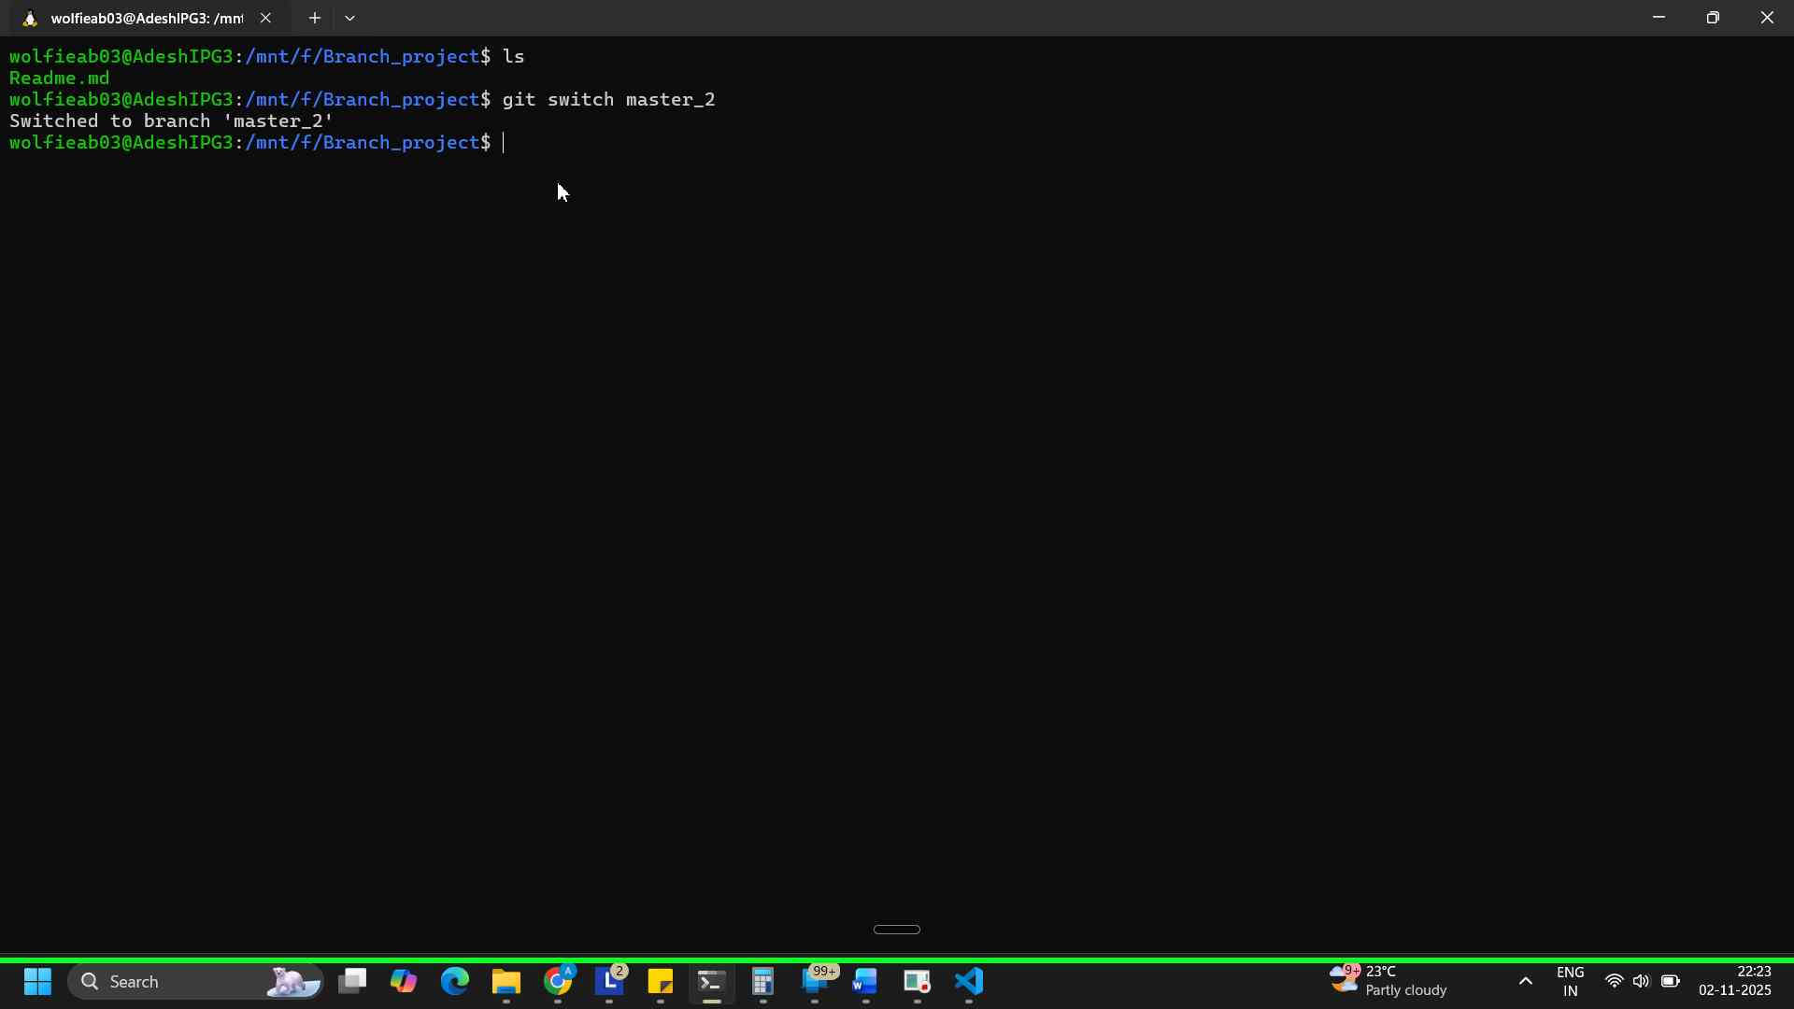
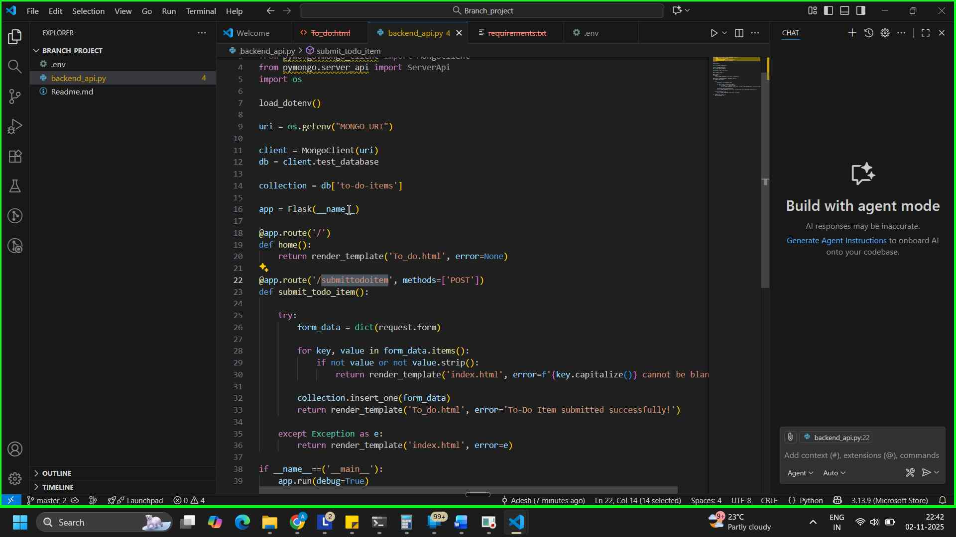
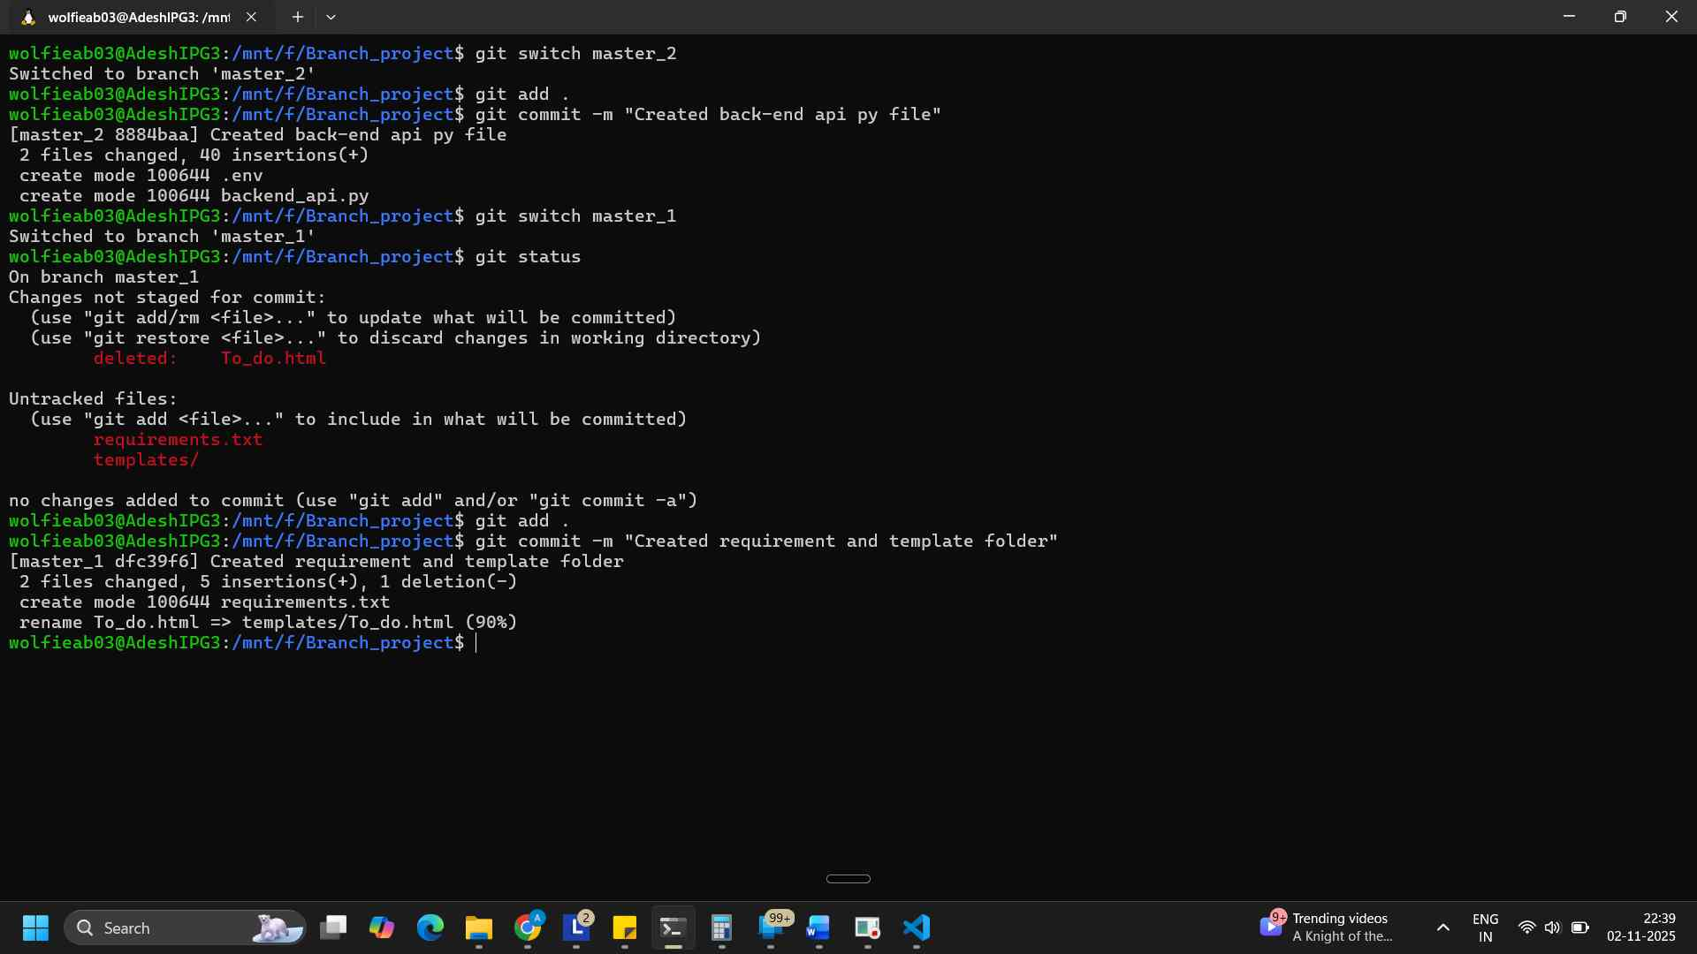
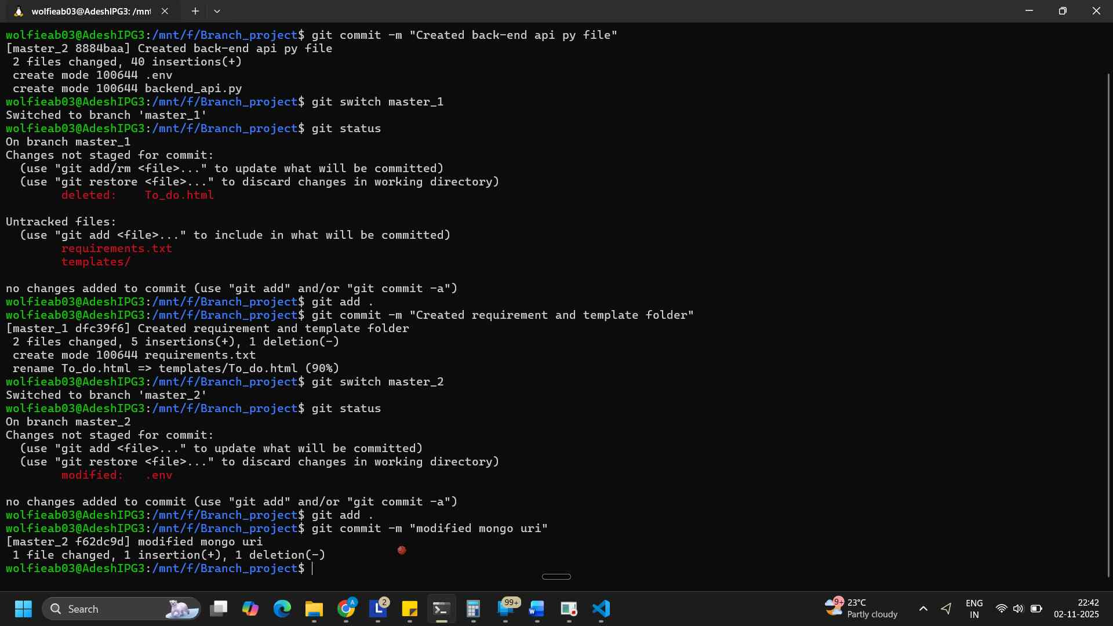
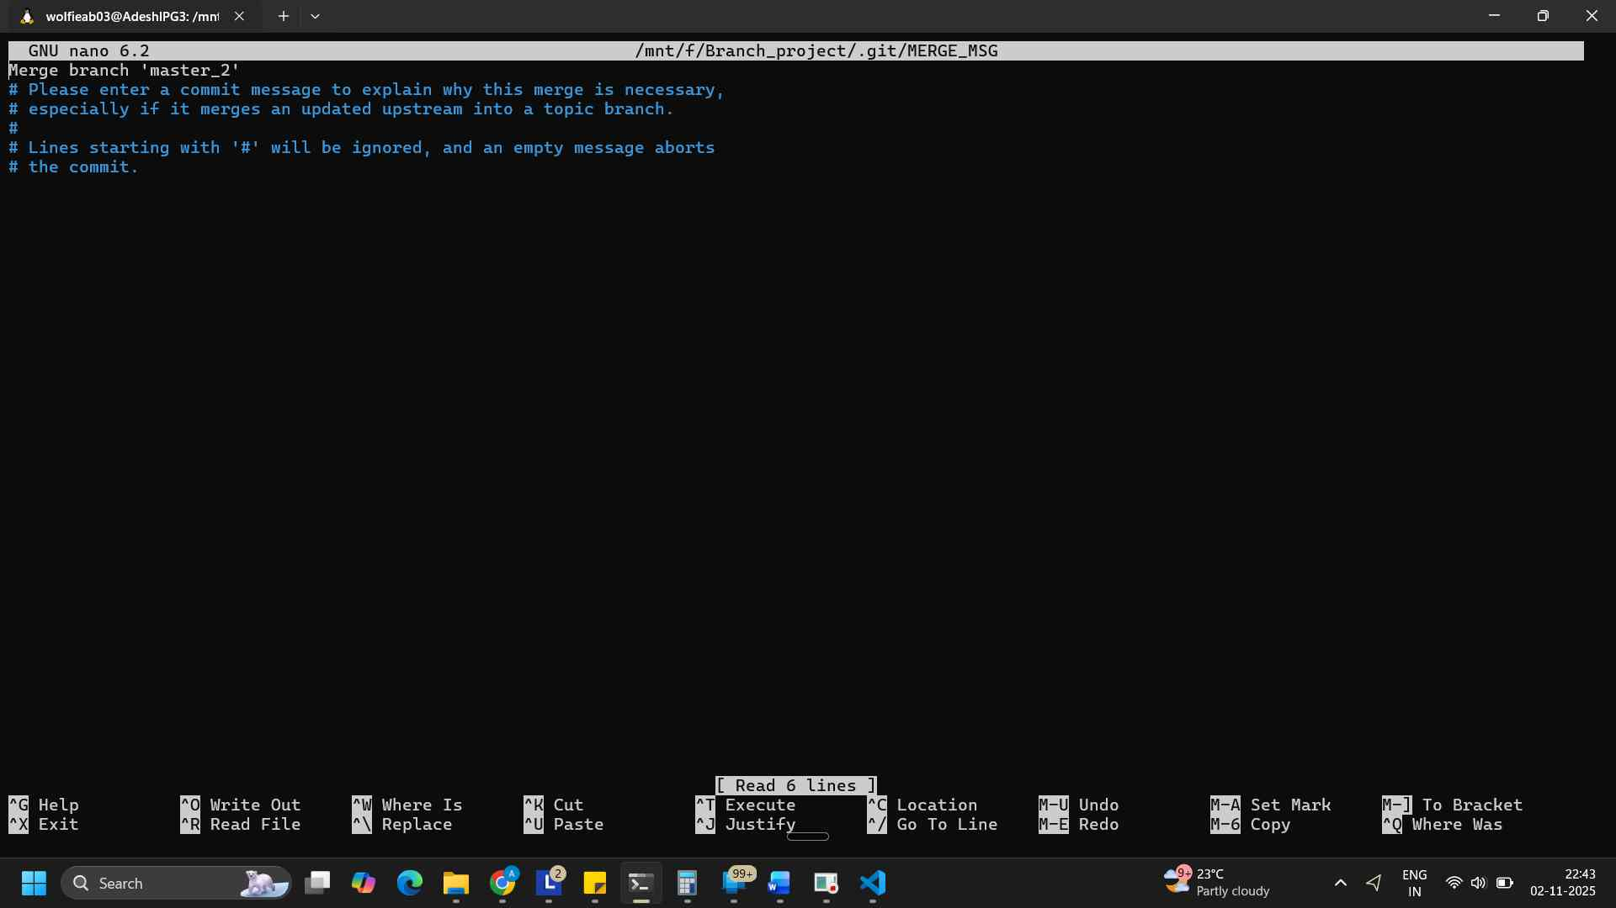
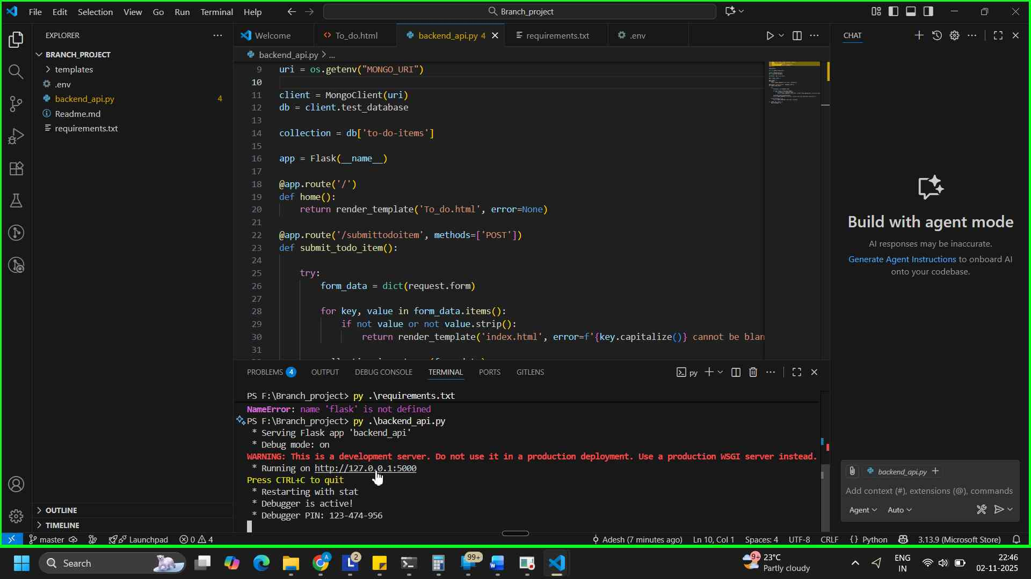
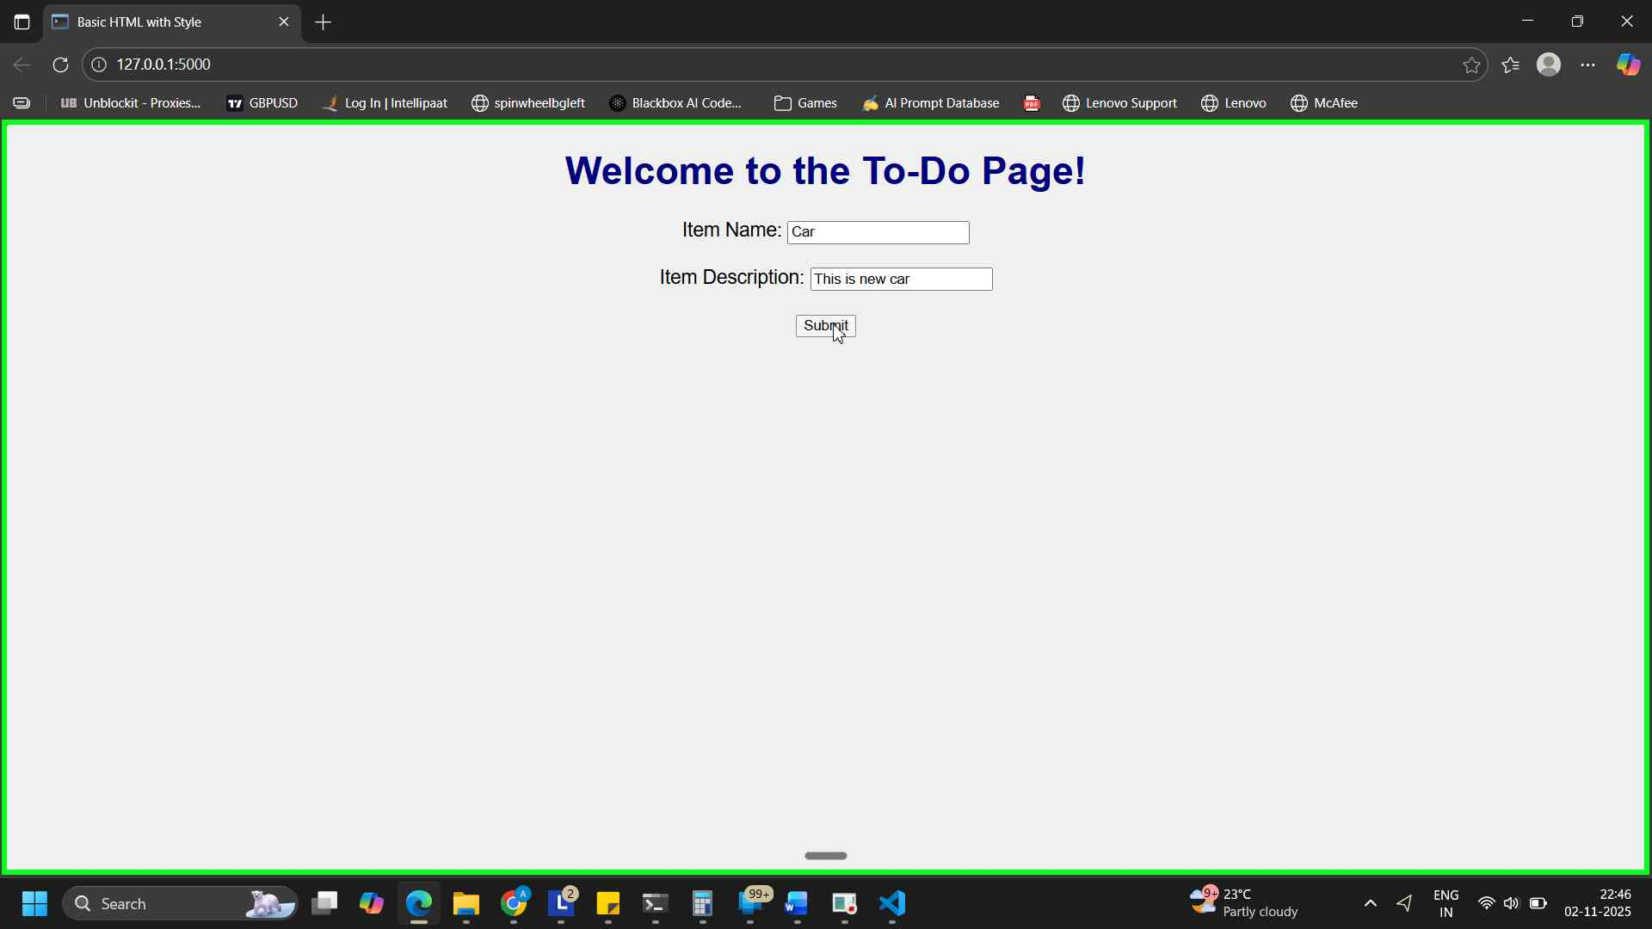
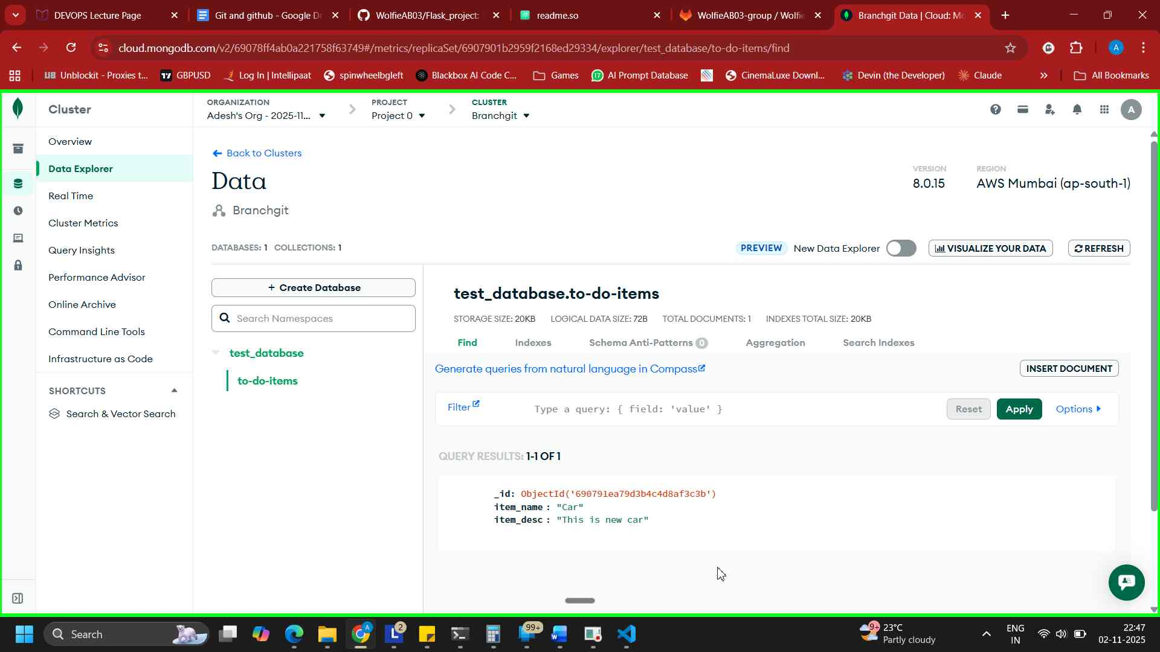

Enhancing the To-Do Form in master_1:
- In the master_1 branch, add the following fields to the To-Do form:
  - Item ID
  - Item UUID
  - Item Hash
- Committing in Sequence:
- Add and commit each field separately in the following order:
  - First commit: Add Item ID field.
  - Second commit: Add Item UUID field.
  - Third commit: Add Item Hash field.
- Merging to main:
- Merge the master_1 branch into the main branch.
- Git Reset and Commit Deletion:
- In the main branch, use Git Reset to roll back to the commit where only the Item ID field was added.
- Use git reset --soft to ensure changes remain staged.
- Re-commit this state to the main branch.
- Merge this updated state to the main branch.
- Rebasing Changes:
- Rebase the updated changes in the main branch to the master_1 branch.
Clarification:
  - During rebasing, preserve individual commits to maintain the commit history for each change (i.e., do not squash commits).
Use git rebase main master_1 to integrate changes from the main branch back into the master_1 branch.

Solution -
